

Universal Design Components
System Integration Information

Moeller Mfg. Co., Inc.
30100 Beck Rd.
Wixom, MI 48393
(248) 960-3999
www.moelleraircraft.com
Proprietary Information
universal_design_components.doc
Issued Oct 12, 2006
Click-Loc™ Universal Design Integration

Click-Loc™ Universal Design components can be used with various types of flare, flareless and dynamic beam seal fittings. The overall design concept is to maintain the established functional characteristics of previously standardized fittings, and make only minimal changes as required to incorporate the Click-Loc™ components. These changes are essentially two-fold as follows.

The standard male fitting end (e.g. AS4395, MS33514, and AS85421) is supplemented by the addition of a shoulder immediately behind the thread relief. This shoulder is machined to a precision diameter and the Click-Loc™ lockring is installed on this diameter and retained by a controlled interference fit. The lockring locates against a suitable surface behind the shoulder to maintain the required axial position of the lockring relative to the end of the fitting end. It is important to note that this change does not in any way affect the material, wall strength, thread engagement, or sealing surface geometry of the standard male fitting end. It does however, increase the overall length by .125 inch. Bulkhead fittings, jam nuts, unions (and elbows and tees) are similarly revised by adding .125 inch long shoulders to allow for the lockring installation. Bulkhead fittings and unions with Click-Locs™ on both sides are .250 inch longer than standard ones. Click-Loc™ lockrings are also available to fit Rosan-type port adapters, and those adapters are not changed in any way.

Most standard tube coupling nuts have a +/- .005 inch tolerance “barrel diameter” inboard of the hex (Ref AN818 Dia. C, MS9197 Dia. C). The tube coupling nut is altered by holding that barrel diameter to a precision dimension for a specified length. The Click-Loc™ sleeve is then installed on this diameter and retained by a controlled interference fit. The revised barrel diameter falls within the tolerance range specified by the standard tube coupling nut drawing and alteration of standard nuts is usually possible. It is important to note that this change also does not in any way affect the material, thread engagement, wall strength, or clamping surface geometry of the standard tube coupling nut. It does however in most cases decrease the length of wrenching hex, but still leaves sufficient hex length for proper tightening of the nut.

These changes to the male fitting end and tube coupling nut are such that when the entire fitting is assembled, the Click-Loc™ lockring will engage the Click-Loc™ sleeve during the last several turns before the nut is seated. We call this the Target Engagement. It should be considered as a design target to be achieved with all dimensions of the male fitting end, the tube end ferrule, and the nut at their mean values and the nut seated. The Click-Loc™ components are designed so that if the Target Engagement is met, all conceivable tolerance stack-ups of all components will be accommodated and there will still be adequate engagement of the Click-Loc™. Additionally, since none of the changes affect the strength or sealing geometry, there should be no need to re-qualify the overall design of revised parts.

There are two series of Click-Loc™ Universal Design fluid fitting components available. For most standard flare and flareless fittings (as well as similar OEM proprietary designs) the SW31504PXX lockring plus SW31511PXX sleeve combination should be used. For dynamic beam seal fittings the SW31600PXX lockring plus SW31659PXX sleeve combination should be used. In all cases, the last two digits of the Click-Loc™ part numbers (e.g. SW31504P06) correspond to the “dash number” size identifier (e.g. –06) of the standard fittings. The following sheets provide all basic engineering data necessary to incorporate these Click-Loc™ Universal Design components to most common types of fluid fittings. If you have a unique application not covered here or need any additional information please do not hesitate to call us.



Click-Loc™ Target Engagement

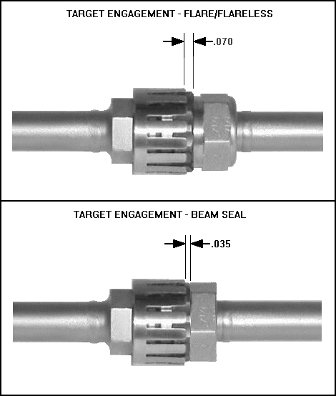

The Target Engagement dimensions shown above are the dimensions from the end of the lockring fingertips to the end of the sleeve. These dimensions apply with all relevant dimensions of the male fitting, tube coupling nut, and tube end ferrule at their mean value and with the nut fully seated. These are system engineering design targets and when met the Click-Loc™ will accomadate the normal tolerance stack-up of all component parts and function properly.

These Target Engagement dimensions are met by controlling the axial position of the Click-Loc™ sleeve on the tube coupling nut. The interface dimensions for the tube coupling nuts that we have provided should allow sufficient barrel length (Dimension C) to enable the sleeve to be correctly positioned in all possible combinations of male fitting, tube coupling nut, and tube end ferrule component types. However, since there are so many possible component combinations, plus other factors beyond our control (e.g. bulkhead thickness, proprietary fitting end designs), it is the customer’s responsibility to establish the correct axial position of the sleeve on the nut and verify these Target Engagement dimensions are met.

Click-Loc™ Sleeve Position to achieve Target Engagement

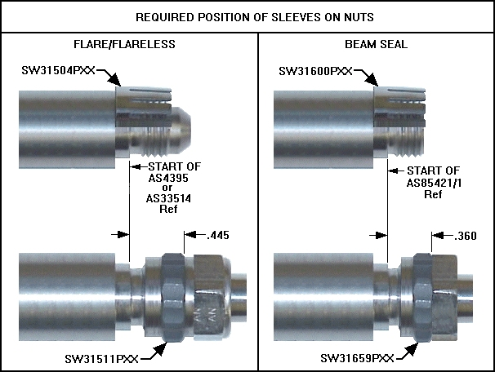

- Applies with all dimensions of all components on the mean and the nut seated
- For use with all sizes and types of fittings
- Applies with fitting end standard dimensions as noted
- NOTE – these dimensions will result in the proper Target Engagement

Click-Loc™ Flare/Flareless Interface Dimensions

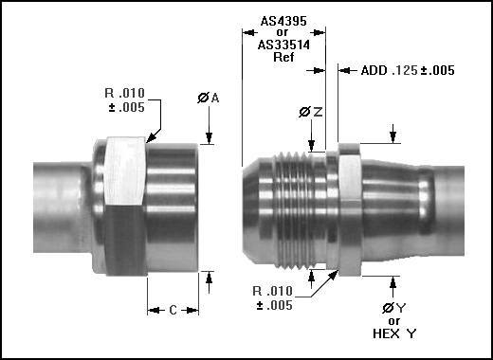

FITTING SIZE | ∅ A +/- .0005 | C +/- .005 | ∅Y +/- .010 | ∅ Z +/- .0005
-04 | .5455 | .380 | .563 | .4430
-05 | .6105 | .381 | .625 | .5060
-06 | .6735 | .421 | .688 | .5680
-08 | .8605 | .367 | .875 | .7560
-10 | .9855 | .341 | 1.000 | .8810
-12 | 1.1755 | .311 | 1.188 | 1.0680
-16 | 1.4275 | .325 | 1.438 | 1.3180

- Applies to standard flare and flareless fittings
- For use with SW31504PXX lockring plus SW31511PXX sleeve combinations
- If using a hex for “Y”, tolerance to be +.003/-.004 inch
- Except as tabulated, all dimensions and tolerances per standard designs
- NOTE – The male fitting (and overall length of the assembled fitting) is .125 inch longer than standard

Click-Loc™ Beam Seal Interface Dimensions

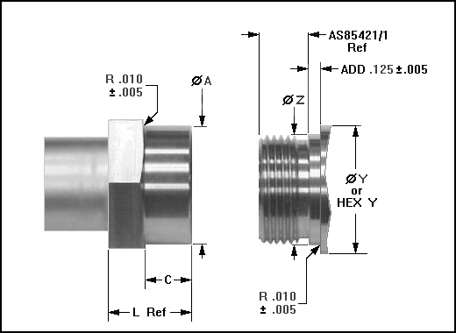

FITTING SIZE | ∅ A +/- .0005 | C +/- .005 | ∅Y +/- .010 | ∅ Z +/- .0005 | L (Ref)
-04 | .5425 | .291 | .563 | .4430 | .454
-05 | .6055 | .285 | .625 | .5060 | .459
-06 | .6685 | .279 | .688 | .5680 | .518
-08 | .8555 | .279 | .875 | .7560 | .510
-10 | .9805 | .271 | 1.000 | .8810 | .571
-12 | 1.1055 | .260 | 1.125 | 1.0065 | .637
-16 | 1.3555 | .247 | 1.375 | 1.2565 | .705

- Applies to standard beam seal fittings
- For use with SW31600PXX lockring plus SW31659PXX sleeve combinations
- Except as tabulated, all dimensions and tolerances per standard designs
- If using a hex for “Y”, tolerance to be +.003/-.004 inch
- NOTE – The male fitting (and overall length of the assembled fitting) is .125 inch longer than standard

Click-Loc™ Bulkhead Fittings and Jam Nuts

Interface Dimensions

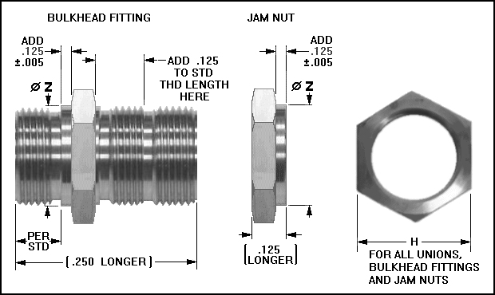

FITTING SIZE | H HEX | ∅ Z +/- .0005  Flare/Flareless | ∅ Z +/- .0005  Beam Seal
-04 | .740 - .753 | .4430 | .4430
-05 | .802 - .815 | .5060 | .5060
-06 | .865 - .878 | .5680 | .5680
-08 | 1.115 – 1.128 | .7560 | .7560
-10 | 1.238 – 1.253 | .8810 | .8810
-12 | 1.363 – 1.378 | 1.0680 | 1.0065
-16 | 1.613 – 1.630 | 1.3180 | 1.2565

- Applies to standard flare, flareless and beam seal bulkhead fittings and jam nuts
- For use with SW31504PXX (for flare/flareless) and SW31600PXX (for beam seal) lockrings
- Except as tabulated, all dimensions and tolerances per standard designs
- NOTE – The overall length of the bulkhead fitting is .250 inch longer than standard

Click-Loc™ Unions Interface Dimensions

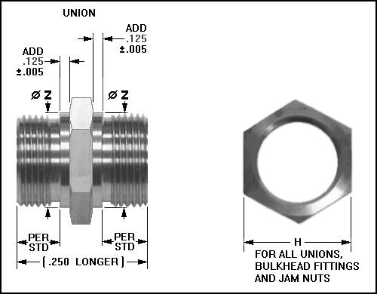

FITTING SIZE | H HEX | ∅ Z +/- .0005  Flare/Flareless | ∅ Z +/- .0005  Beam Seal
-04 | .740 - .753 | .4430 | .4430
-05 | .802 - .815 | .5060 | .5060
-06 | .865 - .878 | .5680 | .5680
-08 | 1.115 – 1.128 | .7560 | .7560
-10 | 1.238 – 1.253 | .8810 | .8810
-12 | 1.363 – 1.378 | 1.0680 | 1.0065
-16 | 1.613 – 1.630 | 1.3180 | 1.2565

- Applies to standard flare, flareless, beam seal and combination unions
- For use with SW31504PXX (for flare/flareless) and SW31600PXX (for beam seal) lockrings
- Except as tabulated, all dimensions and tolerances per standard designs
- NOTE – The overall length of the union is .250 inch longer than standard

Click-Loc™ Component Envelope Dimensions

